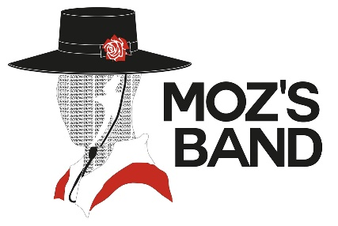
PRESS RELEASE 30.10.21
For Immediate Release

Film maker seeks East Midlands memories of the golden age of carnival bands

Former members of the East Midlands’ colourful carnival bands are being invited to share their stories and pictures with a professional film-maker who is planning to create a documentary telling the story of how they helped bring communities together and put the region on the map.

Derby-born actor, writer and director David Chabeaux, who has starred in Hollyoaks and Bulletproof and has just finished filming for the upcoming season of Peaky Blinders, is putting the film together to celebrate the heyday of the East Midlands carnival bands in the latter half of the 20th Century.

David is making the film in memory of his grandfather Maurice “Moz” Ward, who led the Derby
Serenaders Showband to three European and 23 UK marching band titles and an appearance on BBC’s Generation Game. A welder for British Rail in Derby, Moz’s music and leadership inspired thousands of other musicians in carnival and marching bands across towns and cities throughout the East Midlands.

David, 45, said: “Moz was my grandfather so I literally grew up around this extraordinary man and musical community. I’ve been attracted to the idea of this project for a long time because the subject matter has never left me. We all want to belong, to have purpose in our lives, and in this hyper-materialistic world, the more we discover that trying to fill the void inside us with ’stuff’ doesn’t work, the more there’s a tendency to search for authentic ways to find belonging and purpose without it. My grandfather’s story is obviously very important to me and I’m interested in the journey he took – as a musician, leader and a working-class man – inspiring me and so many others, with the promise of money and ‘stuff' nowhere in sight. The film is an exploration of what it really means to belong, and what that might mean in today’s world.”

At one time there were around 100 carnival bands across the region, ranging from the Grantham Imperials to the Long Eaton Militaires, the Alfreton Messengers to the Wellingborough Redwell, the Chesterfield Musketeers to the Ilkeston Toreadors, the Melton Mowbray Toy Soldiers to the Borrowash Ambassadors to name only a few. Thousands of players aged six to 70 were involved in these flamboyant bands, performing in fabulously eye-catching costumes at carnivals in the UK and abroad.

Similar to the colliery brass bands featured in the film Brassed Off, the carnival bands were made up of workmates at local factories as well as their families and friends, who gave up hours of their spare time to practise playing instruments and marching, giving performances and travelling to competitions.

David, who was born into the Derby Serenaders, will use his documentary to share behind-the-scenes and archive footage and photographs to tell the story of his granddad’s involvement with the banding movement and look back at the competitions, stories and performances of other UK bands.

But he will also reflect on how the demise of the banding movement in the 1990s has left many members, including his father Brian, with a huge sense of loss, and how in today’s world people lack the togetherness and sense of belonging that the banding movement gave its participants back in the day.

He said: “I was two days old when my mum and dad took me on the Serenaders band bus for the first time. My granddad taught me to read and arrange music as well as to play the trumpet, the euphonium and the trombone. I have never known a belonging or a community like it. I miss what it means, and I particularly miss the Serenaders. I can only imagine how many of the thousands of other members of the bands we used to come across at events and competitions feel the same way.

“I want to celebrate that in my documentary but also promote and preserve the legacy of Moz, my
grandfather. He was a hard taskmaster, but he also inspired so many people and the banding movement brought people together. I want to protect the legacy of the band movement before it’s all forgotten, which is why it would be brilliant to reach out to other former band members to find out about their experiences too.”

David has already raised £35,000 and pre-production of the film is now complete. He needs to raise £250,000 in order to complete the filming of the documentary, which will also involve contributions from the USA, South Africa and Scandinavia, where marching bands are still extremely popular. If he gets the funding then he hopes to hold the premiere in his home city of Derby perhaps as early as next summer. Anyone who would like to share memories or otherwise engage with the 'Moz’s Band’ film project should visit www.mozs.band

ENDS

Photos show: (1): Moz Ward; (2): David in the Derby Serenaders with his mum, Shirley Bell, and dad, Brian Bell, on either side; (3): David Chabeaux; (4): The Ward Family, “like the banding mafia!”; (5): The Derby Serenaders – David is pictured on the back row, second from left. Moz is the second row from the front, far-right (in the red jacket)

For media inquiries please contact Lucy Stephens on 0771 983 9446 or email lucy@penguinpr.co.uk

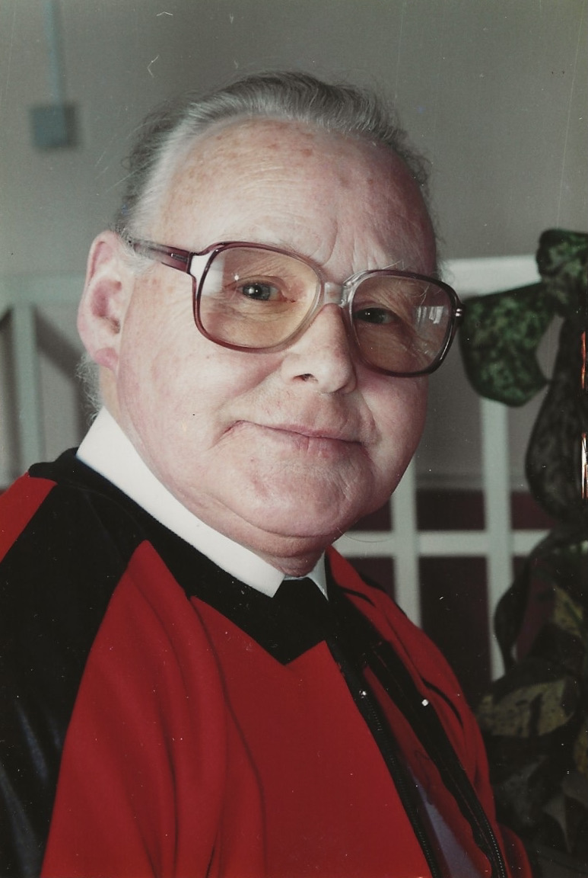
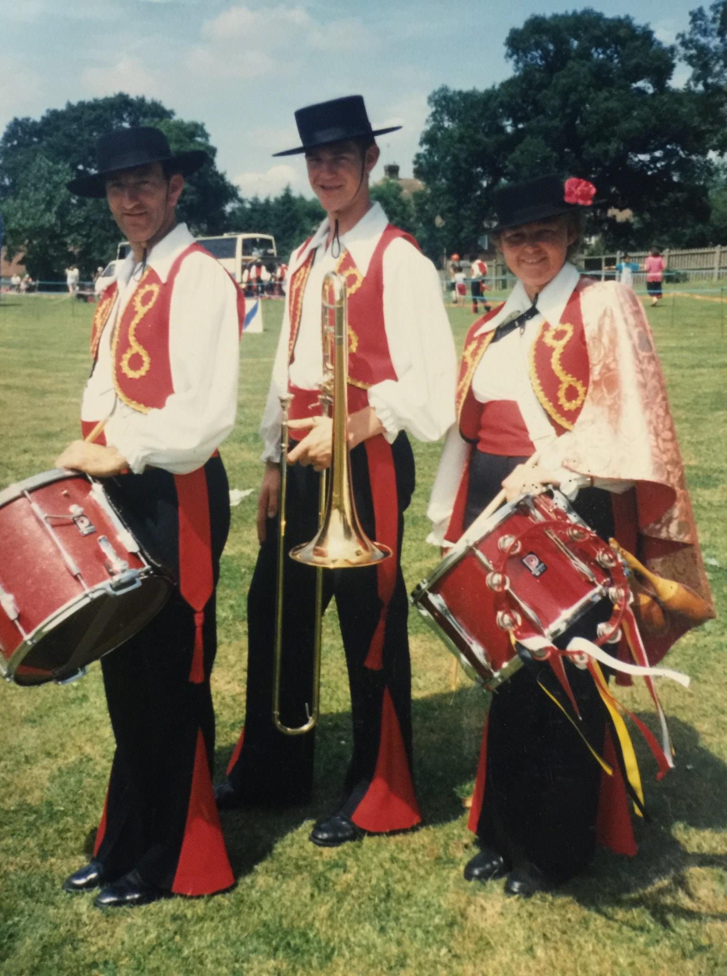
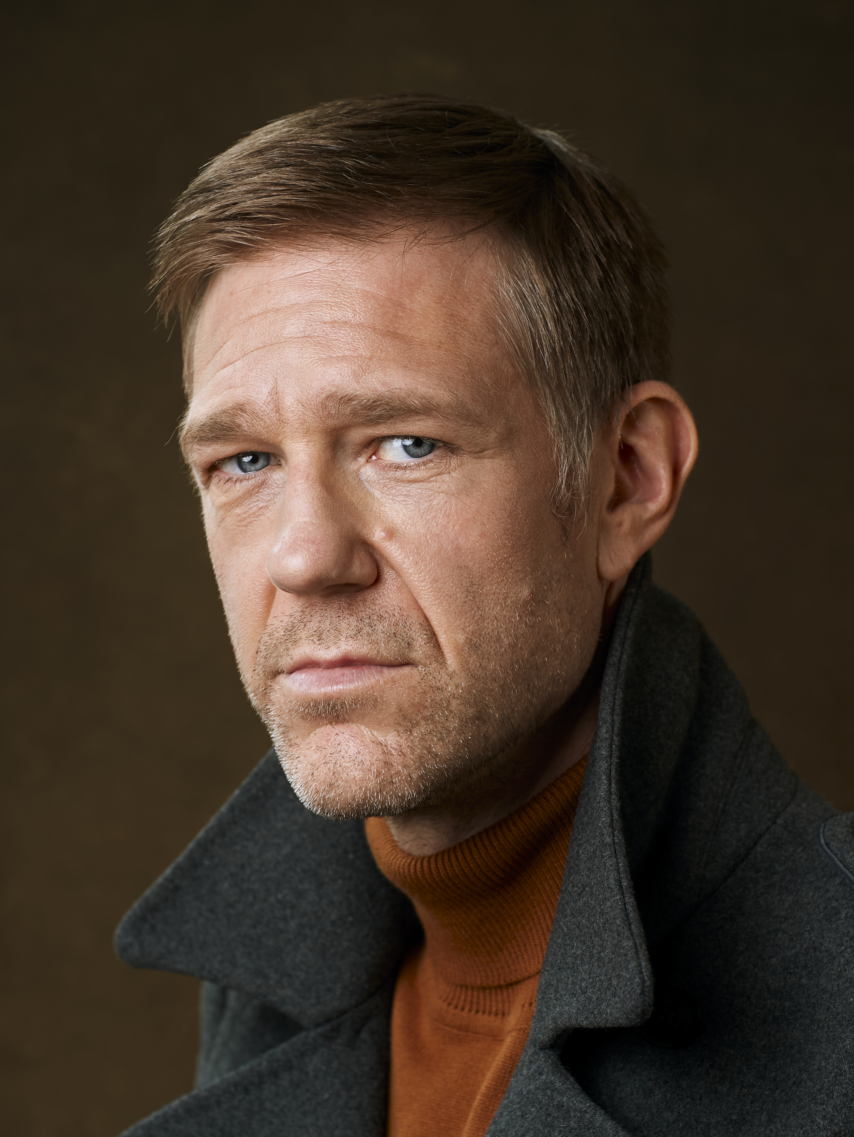
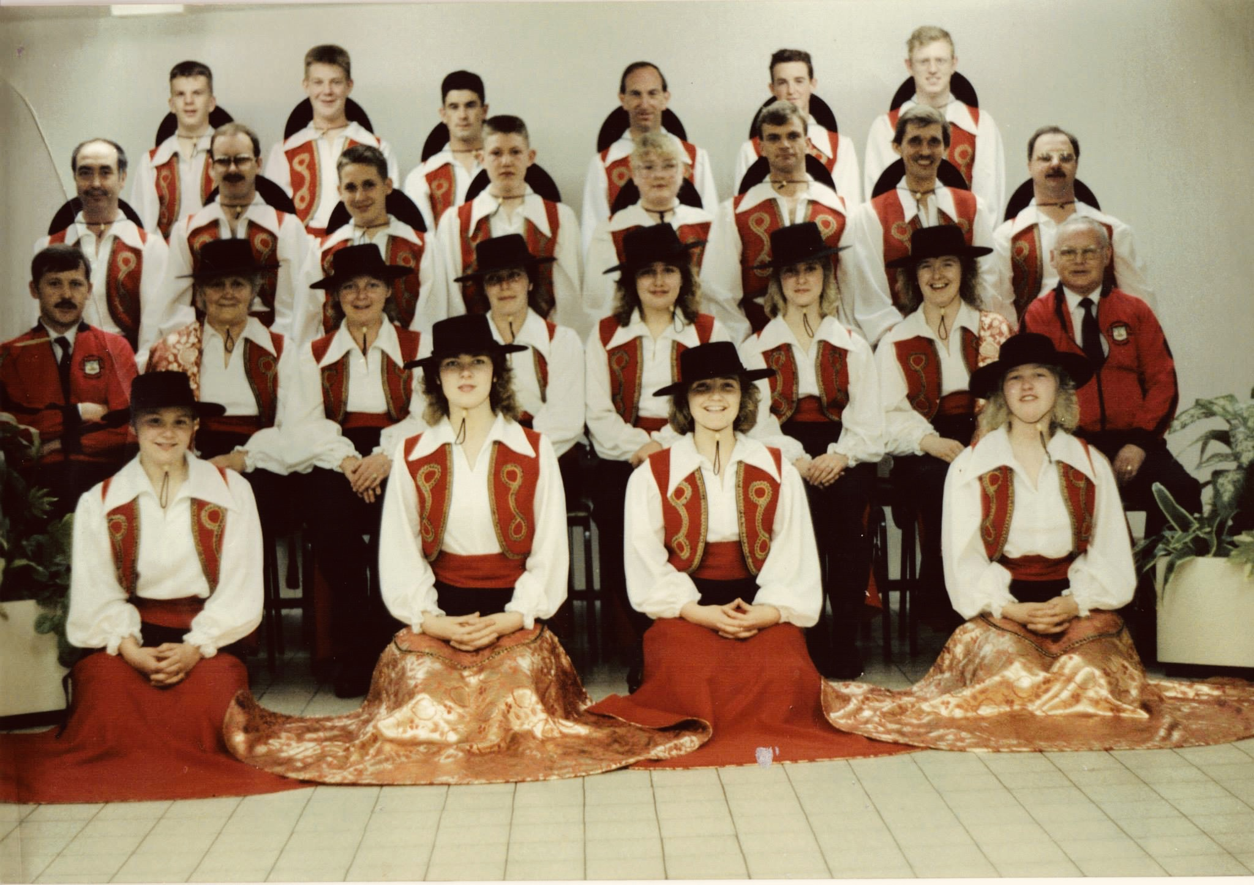
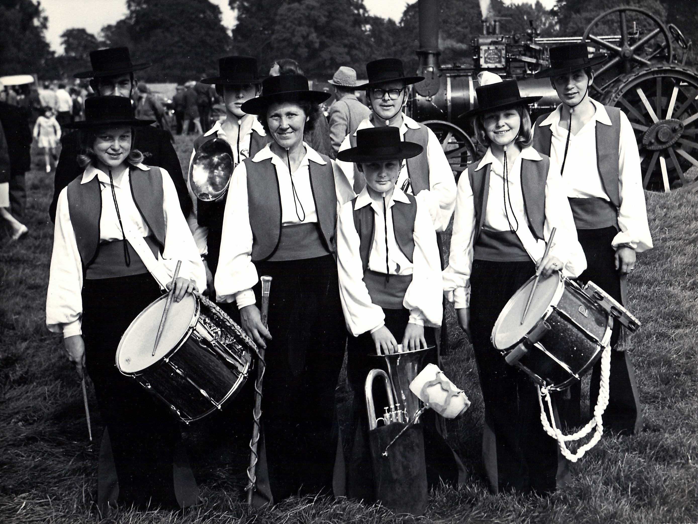

(1)

(2)

(3)

(4)

(5)

